**Inputs**

|  |  |
| --- | --- |
| Energy Converter Specifications | |
| Engine | Cummins Tuned |
| Engine weight | 228 |
| Engine power | 160 |
| Engine RPM range | 4500 |
| Engine peak torque | 550 |
| Generator | Yasa P400 |
| Generator weight | 30 |
| Generator RPM range | 8000 |
| Generator peak torque | 371 |
| Generator quantity | 2 |
| Generator Efficiency @peak power of engine | 88 |
| Motor Inverter Specifications | |
| Motor | Yasa P400 |
| 30 | 30 |
| Motor RPM range | 8000 |
| Motor peak torque | 371 |
| Motor quantity | 4 |
| Motor peak power |  |
| Motor peak power duration |  |
| Motor continuous power |  |
| Energy Storage Specifications | |
| Max battery capacity | 64 |
| Battery weight | 343 |
| Battery C-Rate max |  |
| Battery max charging power |  |
| Battery duration for max charging | 10 |
| Battery continuous charging | 64 |
| Battery max discharging power | 204.8 |
| Battery duration for max charging | 30 |
| Battery continuous charging | 64 |

**Outputs**

|  |  |
| --- | --- |
| Vehicle Specifications | |
| Vehicle weight | 2649 |
| Final drive ratio | 8.501 |
| Lap time |  |
| Fuel Consumption (mpg) |  |

**Plots: Energy Converter**

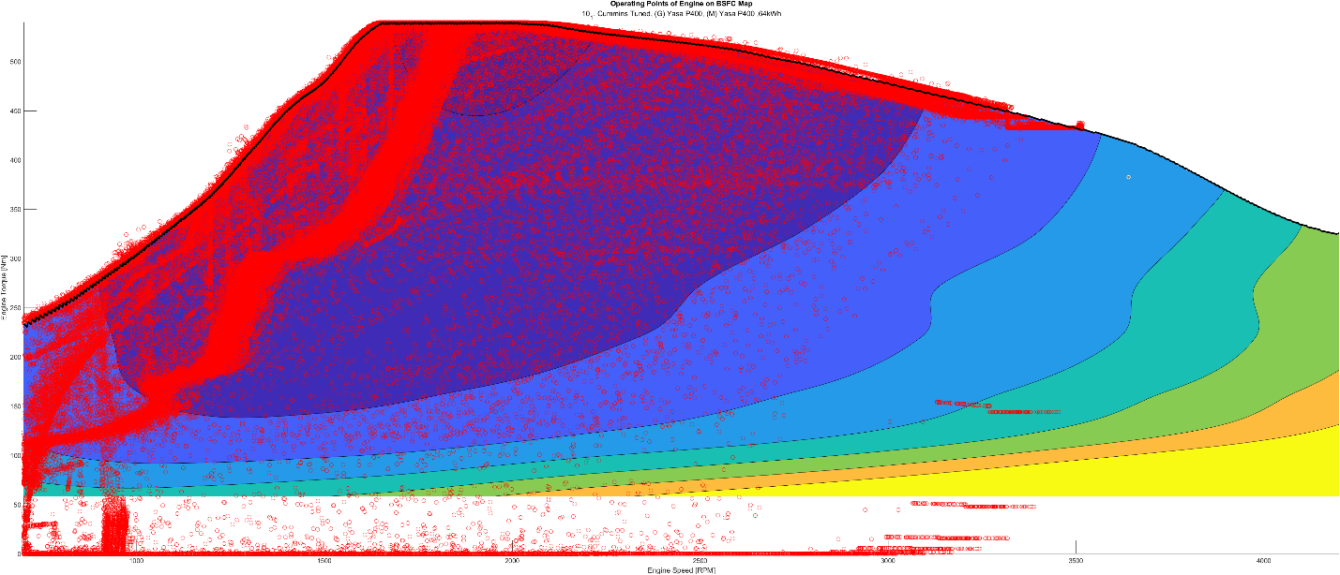

**Plots: Motor**

**Plots: Energy Storage**

